Q.1 Following are the ages (in years) of employees working in a school.

32 34 48 31 34 27 57 36 49 51 45 29 36 46 46 49 51 47 50 30 35 41 36 47 30 35 48 53 37 47 45 30 50 44 49 43 42 46 28 48 52 36 43 38 39 50 49 34 36 50

Construct frequency distribution table.

Find out number of classes and find out also width of the class.

Find out Cumulative Relative Frequency and also with graph.

Q.2 Figures regarding the sales (in thousand rupees) of different items in a super mall during four weeks are as follows:

228 125 100 90 115 125 230 220 130 80 95 160 180 200 200 128 120 85 185 140 265 230 135 127 100 145 150 210

Construct frequency distribution table.

Find out number of classes and find out also width of the class.

Find out Cumulative Relative Frequency and also with graph.

Q.3 During a season of 50 days, the data regarding the numbers of roses grown daily on the different plants in a garden are given below. Prepare a frequency distribution from it having one class as 30 – 39.

34 35 37 39 39 54 52 39 71 75 74 76 84 96 23 33 51 39 26 46 65 65 53 53 72 71 84 94 34 24 99 19 18 27 17 38 45 55 57 66 82 85 35 19 18 28 47 52 64 75

Q.4 The daily record of sales of electronic equipment sold by a shopkeeper of electronic items during the month of April in as under. Prepare an exclusive continuous frequency distribution for which one of the classes is 60-70. Hence,

i) Find the number of days during which the sales of equipment are maximum.

ii) State the number of equipment sold for the maximum number of days.

54 58 52 73 57 39 46 64 49 53 75 34 57 68 51 44 34 40 82 88 80 36 85 66 58 41 62 72 80 81

Q.5 Out of 300 persons residing in a region, a sample of 30 persons is selected at random and the heights (in cm) of these selected persons are as under:

163 148 151 162 145 152 149 158 153 149 157 152 145 141 162 168 148 158 149 141 146 155 159 153 161 153 162 160 154 165

**Qualitative Data -**

Q.1 On the basis of a study of different branches of a co-operative bank of Ahmedabad city, the following information is obtained. There are 20 security personnel, 30 peons, 40 clerks and 8 managers in the bank. Express this information in a table.

Q.2 On the basis of a study of different branches of a co-operative bank of Ahmedabad city, the following information is obtained. In this bank, out of 20 employees working as security personal, 6 are females, out of 30 peons, 10 are females, out of 40 clerks, 25 are females and out of 8 managers, 3 are females.

Express this information in a table.

Q.3 On the basis of a study of different branches of a co-operative bank of Ahmedabad city, the following information is obtained. In this bank, out of 20 employees working as security persons, 7 males are married and out of 6 females, 4 are married. 12 peons out of 20 male peons are married and 10 female peons are unmarried. Out of 40 clerks, 25 are females and of them 12 are married whereas 7 male clerks were married and out of 8 managers, all 3 female manages are unmarried and all the male managers are married.

Express this information in a table.

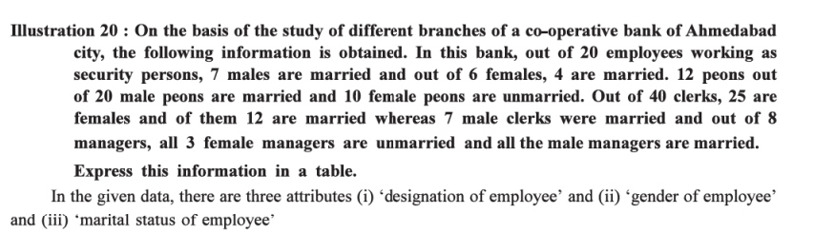

Q.9